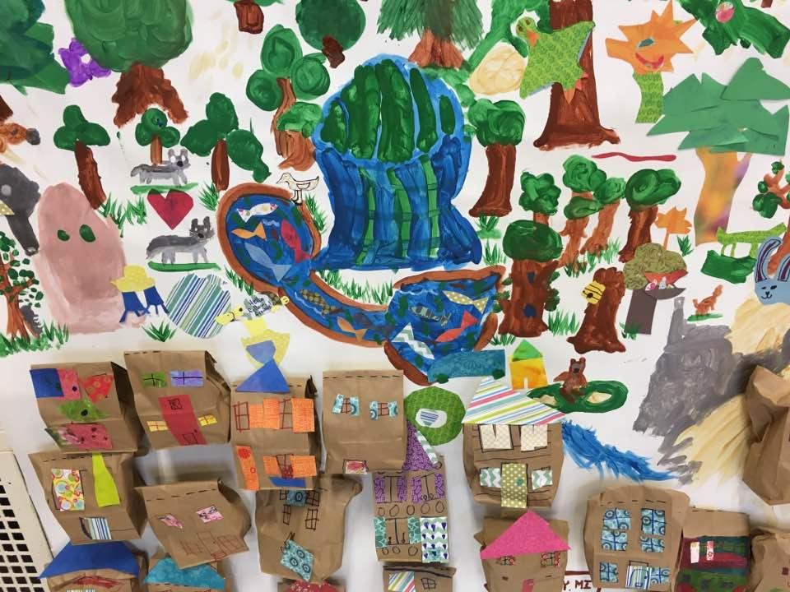
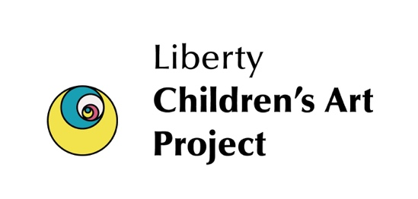
Big Bay
Summer Art Camp
The Art Garage with Liberty Children's Art Project (LCAP)
August 4-8 Monday-Friday 1:00-2:30 (1-9th Grade)
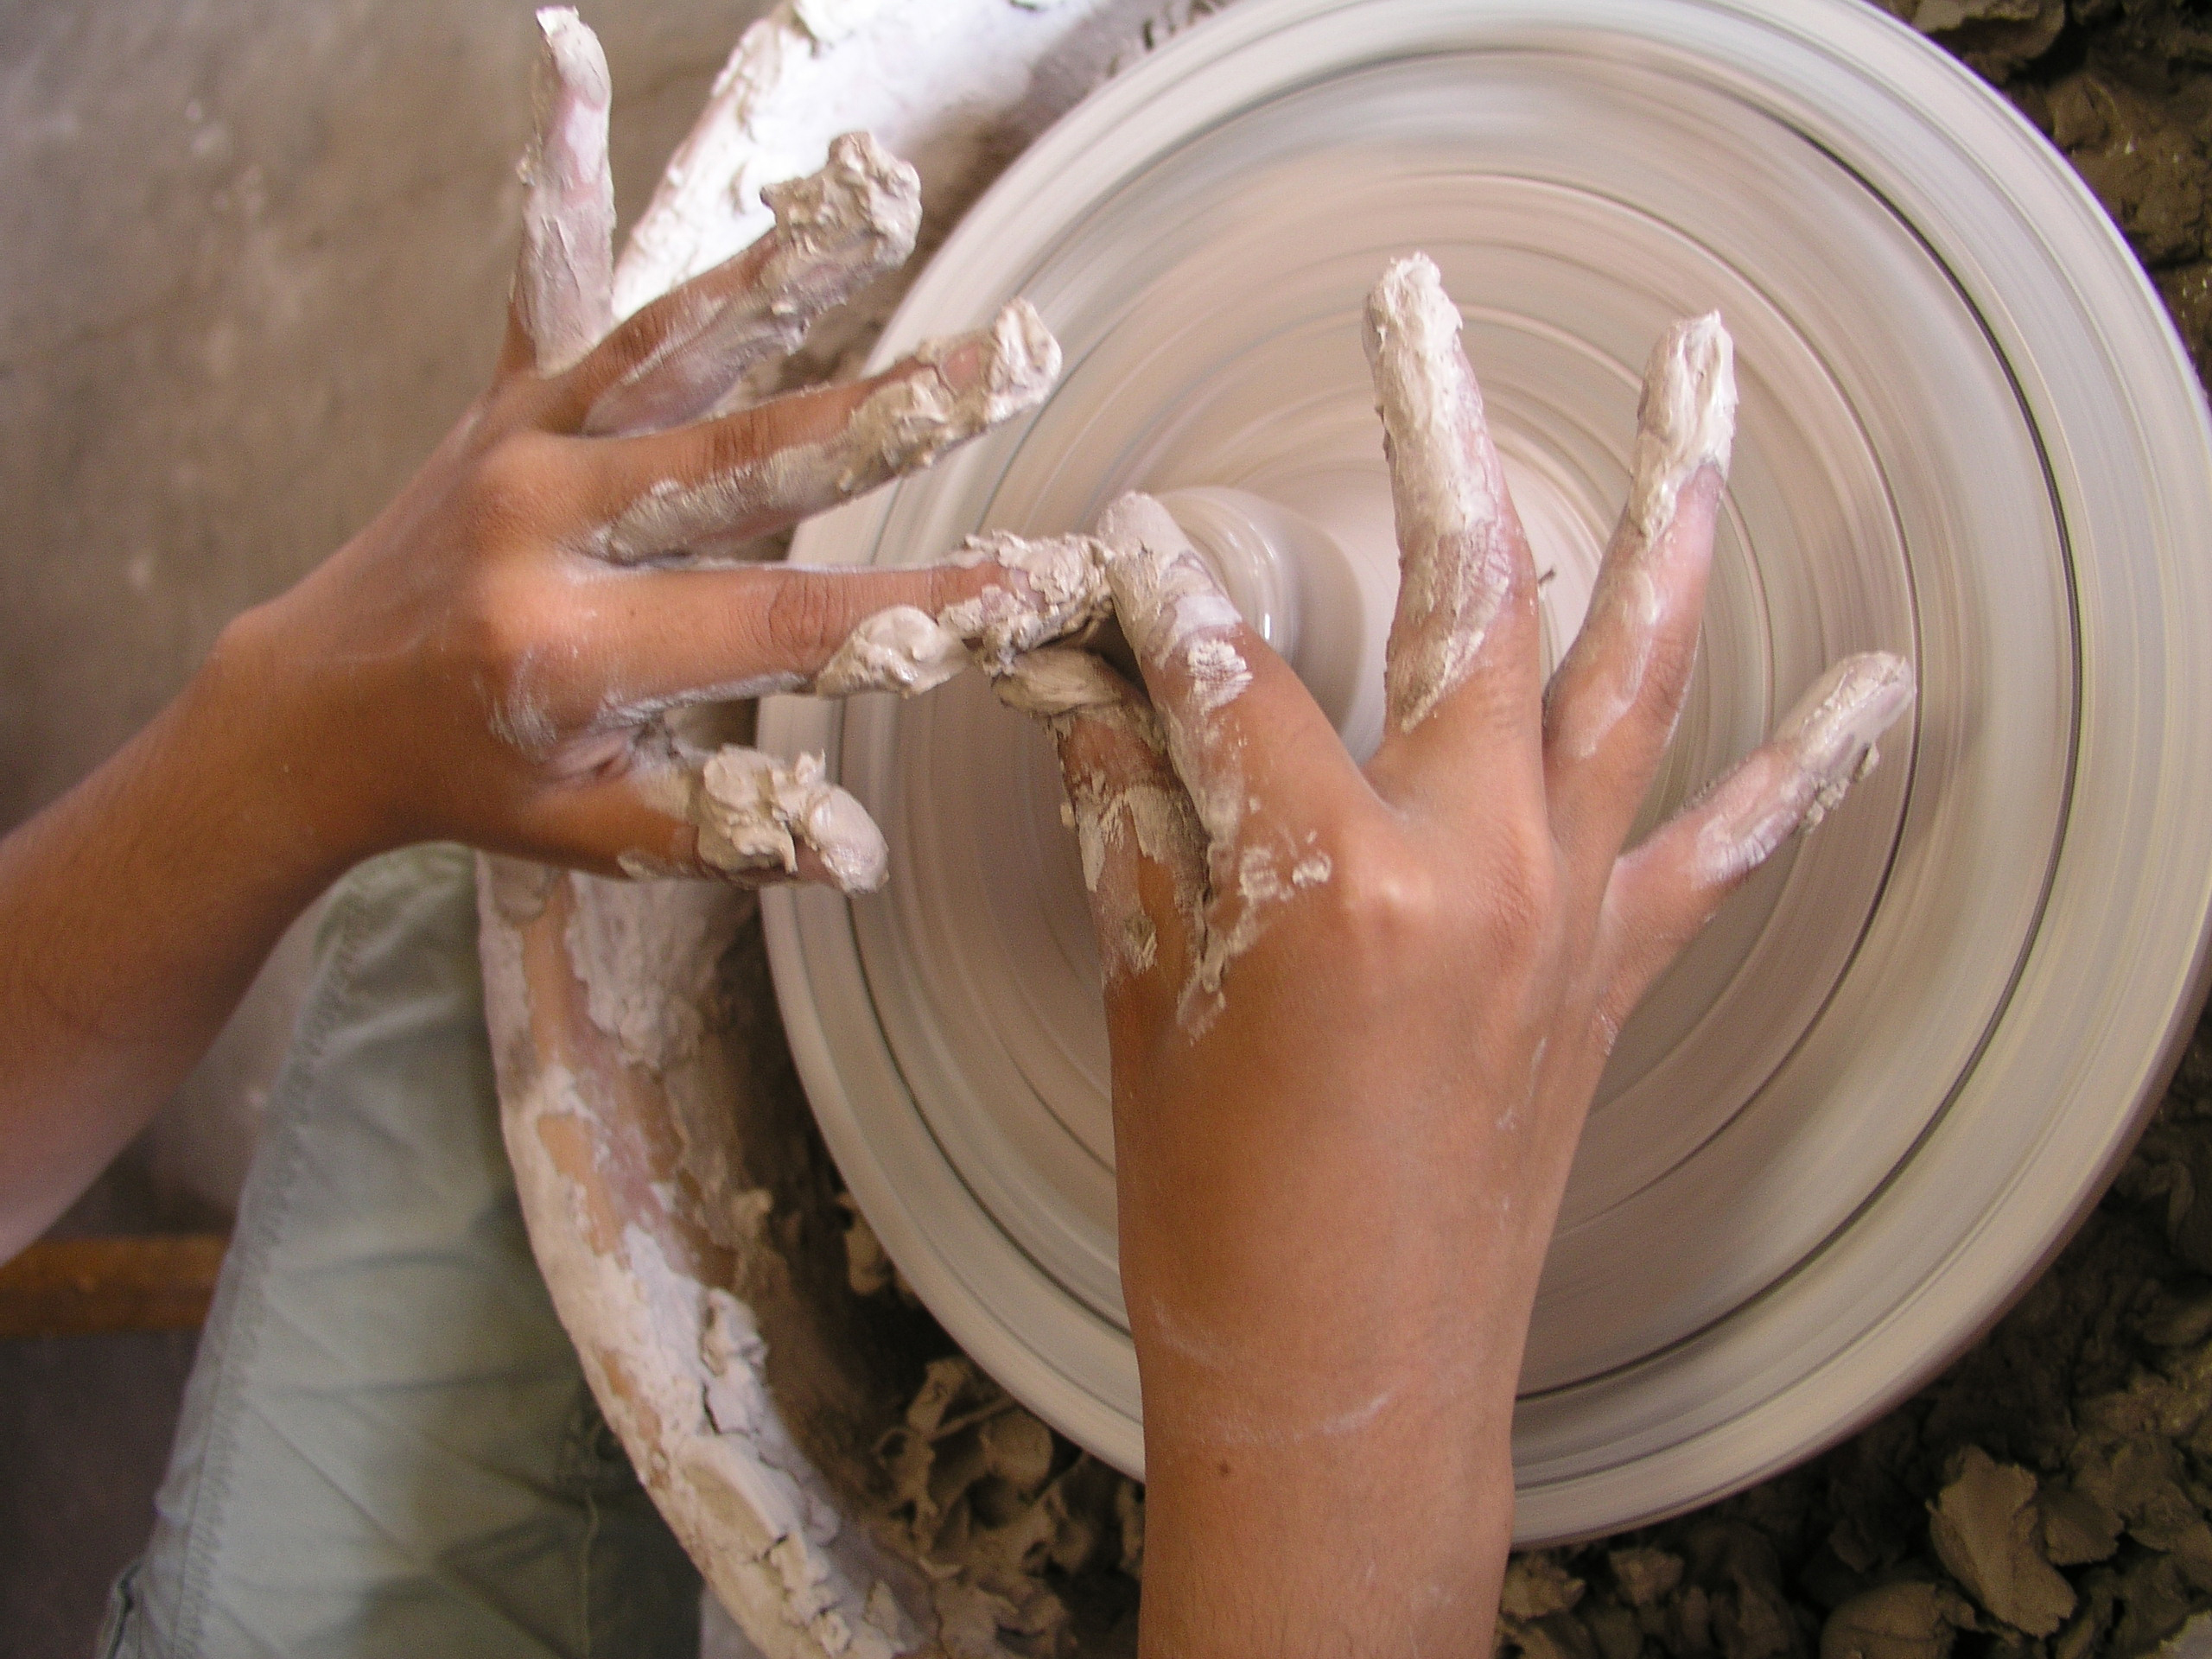
‘Think like an Artist!’ Painting, Printmaking, Mural Creation and Clay, use a variety of chosen art methods/materials to create unique art work for younger students (1st- 4th) with artist Chloe Fortune and ‘Just Clay- Throwing on the Potters Wheel, Carving in Clay and Clay Sculpture’ for 5th-9th grade students with ceramic artist Carol Phillips.

These classes will all meet at the Powell Township School Outdoor Art Garage 101 Deutsch in Big Bay, MI. Come to some or all days.
These classes are free of charge to Powell Township children but open to ALL children in the area ($25/week, $5 for one-day workshop) thanks to the generous support of Powell Township School, the Hirvonen Foundation and Rotary West.

Register at Powell Township School (345-9355), or with LCAP director, Carol Phillips at 228-3956 or email carolannphillips@hotmail.com

